NRP PAC GENERAL MEETING MINUTES
April 9, 2024
6:30pm - 7:30pm
In Person, Learning Commons
Call to Order: 6:32pm
Greeting and Land Acknowledgment: With deep gratitude and respect, I am honoured to be learning and unlearning on the ancestral and unceded lands of the xʷməθkʷəy̓əm (Musqueam), Sḵwxwú7mesh Úxwumixw (Squamish Nation) & səlilwətaɬ (Tsleil-Waututh Nation).

1. ADOPTION OF THE AGENDA

MOTION: To adopt the agenda for today’s meeting.
MOVED: Karina; Seconded: Emma; All in favour, Carried.

2. APPROVAL OF PREVIOUS PAC MEETING MINUTES ON FEBRUARY 20, 2024

MOTION: To approve the February 20, 2024 PAC Meeting Minutes.
MOVED: Yawen; Seconded: Steve; All in favour, Carried.

3. NRP STAFF REPORT – PRINCIPAL, HENRY PETERS + VP, JULIA CLARK
- School Fees for 2024-2025: $35 supply fee; $9 agenda; $9 book bag; $20 performance fee; $20 activity fee; $5 food prep. This will be available via Cash Online. PAC subsidizes as much as possible.
- NRP is consistently short teachers and support workers. There is a crunch all the time. Administration tries to minimize the impact on students. Innovation: how do we hire teachers for longevity?
- Encourage you to be playfully engaged with your children and technology.
- NRP added a 5th Kindergarten class today. This almost cleared off the waitlist, with the exception of 15 children.
- The four “no parking signs” have been pushed further off the curb to encourage better flow at drop-off at the front of the school. It is working well so far and will be kept as is for the time being to maintain traffic movement.

Q+A

Q: How can we know how many teachers do not have substitutes covering their classroom?
A: You can speak to the trustee and the trustee can get specific numbers from school administration.

4. BUDGET UPDATE

Main Account

- Lunch program is bringing in most of the PAC’s fundraising revenue.
- Learning Communities are used by the teachers to purchase supplies for their classrooms.

Gaming Grant Account
- Funds that have come from the BC government and are given as an amount per student.
- The funds that were spent over the last two months were primarily on Multicultural Week and subsidizing community fieldtrips.
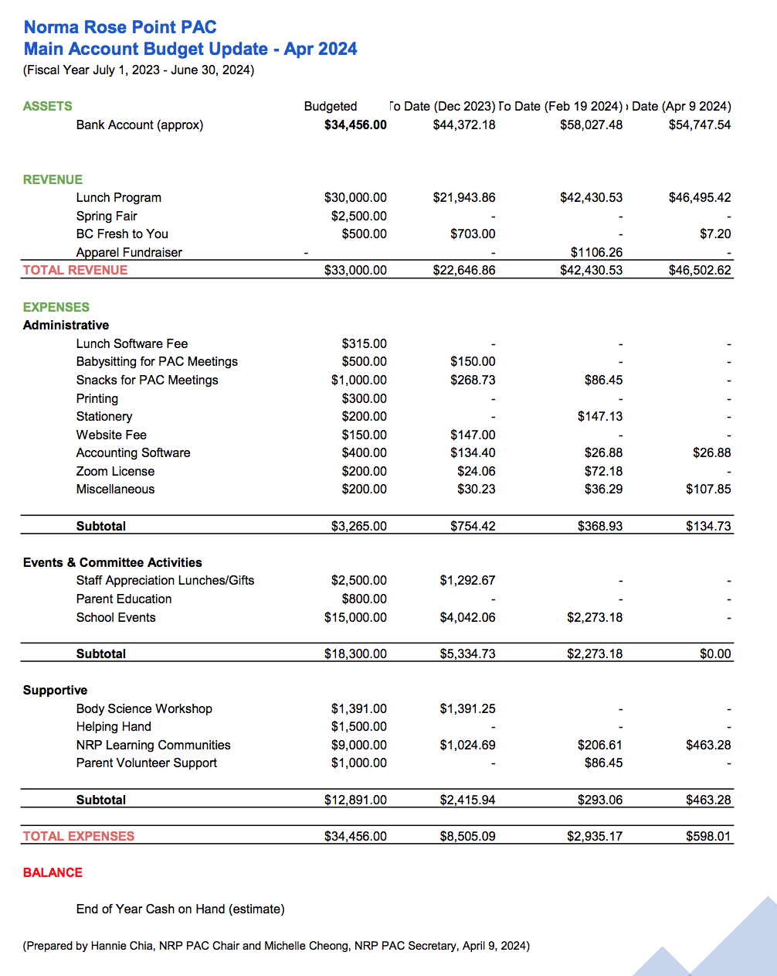

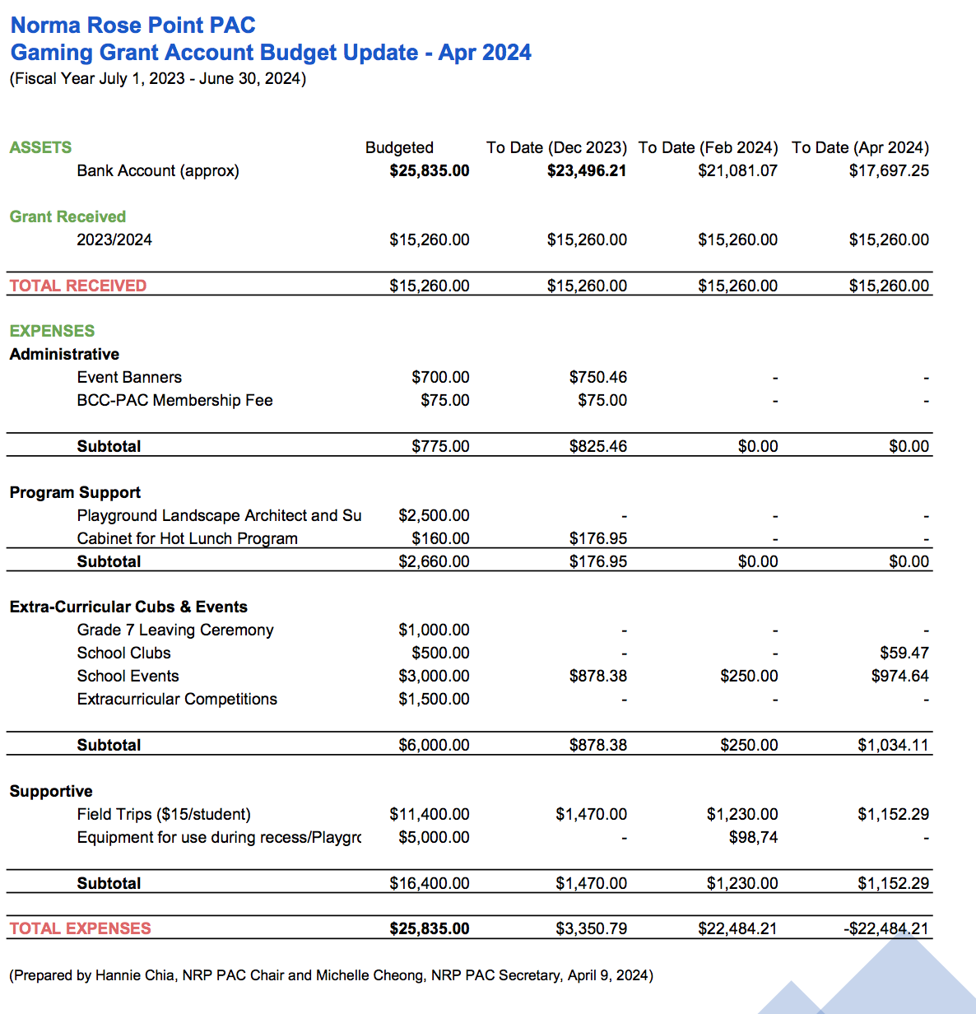

5. MULTICULTURAL WEEK RECAP
- Week of February 26, 2024
- Special Guests:
- Welcoming Ceremony with Alec Dan, Musqueam
- Tae Kwon Do during gym sessions and a performance
- Student performances during lunch
- Multicultural Day on March 1, 2024
- Cultures: Nigerian, Japanese, Spanish, Ukrainian, Chinese, Indian, Taiwanese, Korean
- Debrief: looking at different models to represent Multicultural Week for next year. Please let the PAC know if you would like to be a part of this committee!

6. 2024 SPRING FAIR
- Friday, May 10 from 3:00 – 7:00pm

ALL HANDS ON DECK! We need more volunteers for a successful event! Please look at the signup.com link on the school app.

Find the right volunteer position for you: https://signup.com/go/wtocCQQ

- Food trucks
- UNA will sell popcorn and cotton candy
- Grade 7 baked goods
- Drinks (donated by a PAC member at-large)
- 2 rides
- 3 bouncy castles
- 1 giant slide
- 1 obstacle course
- LOTS of games (Khats community is designing games)
- Face Painting
- Mr. Bubbles – balloon twister!
- Silent auction
- Will’s Jams
- Rock ’n Beau
- Primary Choir
- Gymnastics
- Dance
- The Chickadees
- Kids’ Market
- Community Booths
- Kumakai Karate
- Fire truck
- UBC Thunderbird
- BC Lions’ Leo the Lion

7. BIKE TO SCHOOL WEEK
- June 3 to June 9
Seeking Committee Members
Contact: nrppacbike2school@gmail.com

8. 2024 YEARBOOK SALE
- Sold through School Cash Online – will be posted via School App this week
- Exciting changes:
o Option to purchase soft or hardcovers
o Increasing number of pages from 44 to 90+
o Changed companies from Jostens to Herff Jones
- Regular Sale
o Soft Cover: $30
o Hard Cover: $40

9. PLAYGROUND COMMITTEE UPDATE
- Submitting proposal to Mr. Peters this week: review of work that committee has been done to date including student engagement sessions with intermediate grades. This will be available once playground website is up and running.
- Seeking greenlight from administration; still no word from VSB grounds.
- Next step will be re-engaging vetted Landscape Architect, Kristina Zalite and community fundraising efforts.

10. NEW ITEMS
- Second run of hoodie and t-shirts sales TBD, please stay tuned.
- Review of PAC positions; next month during the AGM there will be voting of the preliminary PAC Executive Committee.
- Parent expressed specific concerns about the Tuesday lunch delivery quality from Bittersweet Kitchen. Yawen (Lunch Coordinator) to address parent’s concerns with them offline.
- If there is a problem with a received or missing lunch, students are encouraged to contact a lunch parent volunteer immediately. Parent volunteers are onsite daily during lunch (11:20-12:50) by the school office to assist students in a timely manner whenever needed.
- Yawen, the Lunch Coordinator, can be contacted directly for any further concerns via email at rosepointpaclunch@gmail.com.

11. GENERAL Q & A

SUBSCRIBE TO NRP PAC POSTS
- https://nrprpac.ca
- Please let us know if you have any feedback on the website.

DOWNLOAD THE NRP APP
- Download on the App Store
- Get it on Google Play

UPCOMING PAC MEETINGS
- AGM: June 18, 2024 (In-Person)
- Interested in joining the PAC? Meet & chat with the current PAC Executive Committee Members!
- Voting for preliminary PAC Executive Committee

Next meeting: June 18, 2024 @ 6:30pm, In-Person
11. TERMINATION OF MEETING – 7:30PM
https://nrppac.ca | rosepointpac@gmail.com

