NRP PAC GENERAL MEETING MINUTES
February 20, 2024
6:30pm - 7:30pm
Zoom Conference Call
Call to Order: 6:35pm
Greeting and Land Acknowledgment: With deep gratitude and respect, I am honoured to be learning and unlearning on the ancestral and unceded lands of the xʷməθkʷəy̓əm (Musqueam), Sḵwxwú7mesh Úxwumixw (Squamish Nation) & səlilwətaɬ (Tsleil-Waututh Nation).

1. ADOPTION OF THE AGENDA

MOTION: To adopt the agenda for today’s meeting.
MOVED: Atul; Seconded: Karina; All in favour, Carried.

2. APPROVAL OF PREVIOUS PAC MEETING MINUTES ON DECEMBER 19, 2023

MOTION: To approve the December 19, 2023 PAC Meeting Minutes.
MOVED: Atul; Seconded: Chin Sun; All in favour, Carried.

3. NRP STAFF REPORT – PRINCIPAL, HENRY PETERS + VP, JULIA CLARK
- Land Acknowledgement; we paddle together. Let’s listen to each other’s stories and histories. These are things that have come out of journey to reconciliation. It is our collective duty to leave each natural space better than we find it. Consider the deep indigenous knowledge and think about how we determine the value of things in our world. Let us live in the gratitude and amazement at the richness and generosity of the world.
- Thank you to PAC for involvement and support.
- NRP School Plan, Goals:
- Continue to strengthen sharing practices horizontally and vertically (grades, communities and divisions interact with each other)
- Continue to integrate authentic indigenous teaching and learning experiences for our students. Thank you to Ms. Nordman for all the ways that she has helped up connect to Indigenous Learning.
- Communicating Student Learning:
- Report cards will come out a week before Spring Break – March 12 – summarizing the richness of the recent conferences.
- Second set of conference concluded last week during the early dismissal days. Thank you, parents and guardian, for participating in them. It was a wonderful opportunity for the students to show off their work.
- Report cards: will continue to have a performance scale (emerging, developing, proficient, extending). Goal for all students is to be at proficient. Teachers are in the process of working on this document. Report cards will be going out on March 12.
- Satisfaction Survey: electronic survey sent out to all district schools. It is a useful tool for schools to gather information from families about their experience at school. Please follow the link, select VSB, NRP and the language you wish to complete the survey in. It helps NRP to set school plan and goals.
- School Goals and Social Responsibility: building a culture of service and stewardship. NRP can continue to focus in on how students serve and show stewardship at all grades.
- Health and Safety: when there are communicable health concerns in the school (i.e. Lice, rashes) in the school, the part of the school that is impacted will be informed. This could be a classroom or a community. We will try and keep you informed on things that as a family you may need to focus on as far as health in your classroom or in great parts of the school.
Q+A

Q: Are their ways to alleviate pick-up and drop-off issues for parents in cars, both at the main office doors and the parking lot? Congestion of parked cars is causing traffic flow issues.
A: Ms. Clark and I have been thinking about ways to alleviate the issue. I have tried moving the drop-off signs further away from the curb. There is more drop-off traffic going into the staff parking lot. People have been ticketed. Ortona Road is narrow and this could be an issue as well. Perhaps the PAC can capture some focus feedback on parking at NRP. I’m open to ideas.

Q: Will there be individual parent-teacher conferences scheduled after Spring Break?
A: There are 3 formal reports this year which is new from previous years. This is a Ministry directive. Formal reports go home in December, March and June. Informal reports – conferences – are held in October and February.
There is always an opportunity to connect with your child’s teacher to schedule follow-up meetings about your child’s learning and development.

NRP Culture: Love and Connection!

4. PAC EXECUTIVE MEMBER CHANGES
Voting in Iris Choi as Lunch Program Volunteer Coordinator

MOTION: To vote in Iris Choi as Lunch Program Volunteer Coordinator.
MOVED: Chin Sun; Seconded: Brandon and Karina; All in favour, Carried. Iris will begin her term after Spring Break.

Thank you, Donna Zhou former Lunch Program Volunteer Coordinator. Donna has been NRP PAC’s lunch coordinator for 3 years.

5. BUDGET UPDATE – CHAIR, HANNIE CHIA
- The PAC Execs are still looking for PAC Treasurer. If you have any experience bookkeeping or budgeting, please email the PAC.
- Interim treasurers are PAC Chair, Hannie and PAC Secretary, Michelle

Main Account
- The lunch program is doing very well. Revenue is steadily increasing. Yawen (Lunch Coordinator) is introducing new vendors and that has helped with variety and interest in the program.
- Apparel fundraiser led by Jake (Event Coordinator) made $1,106.26. This revenue will go towards the new playground build.

Gaming Grant Account
- Funding provided by BC Government
- Multicultural Week will be accessing Gaming Grant funds
- Fieldtrips have been taking advantage of this funding
- Playground Committee will also be using this funding

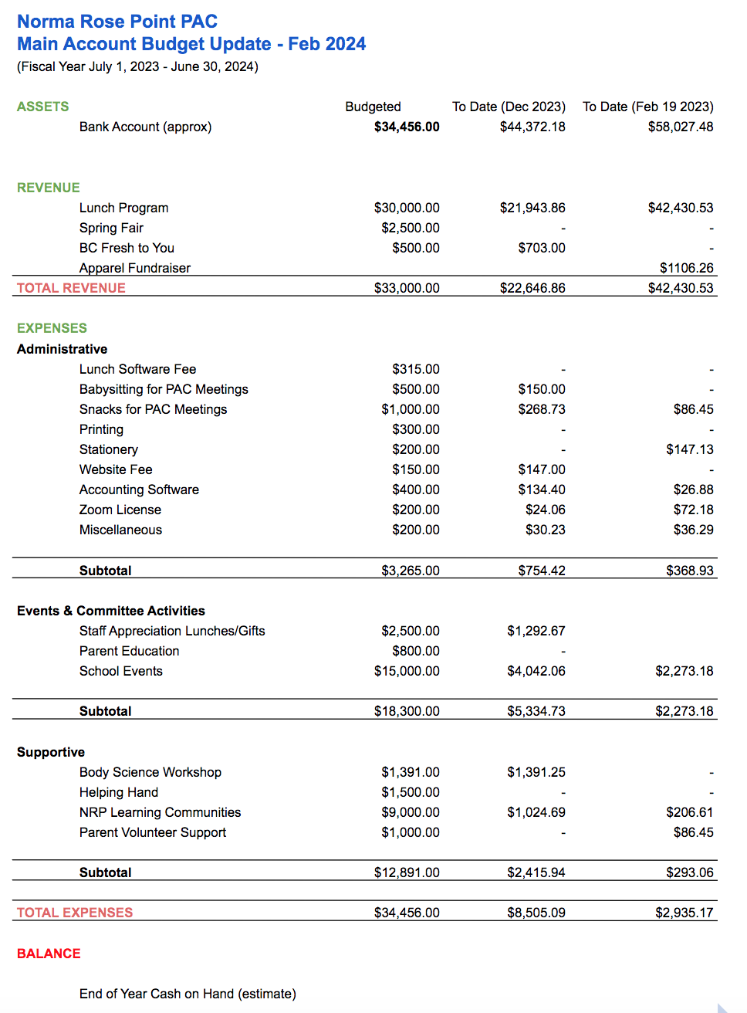

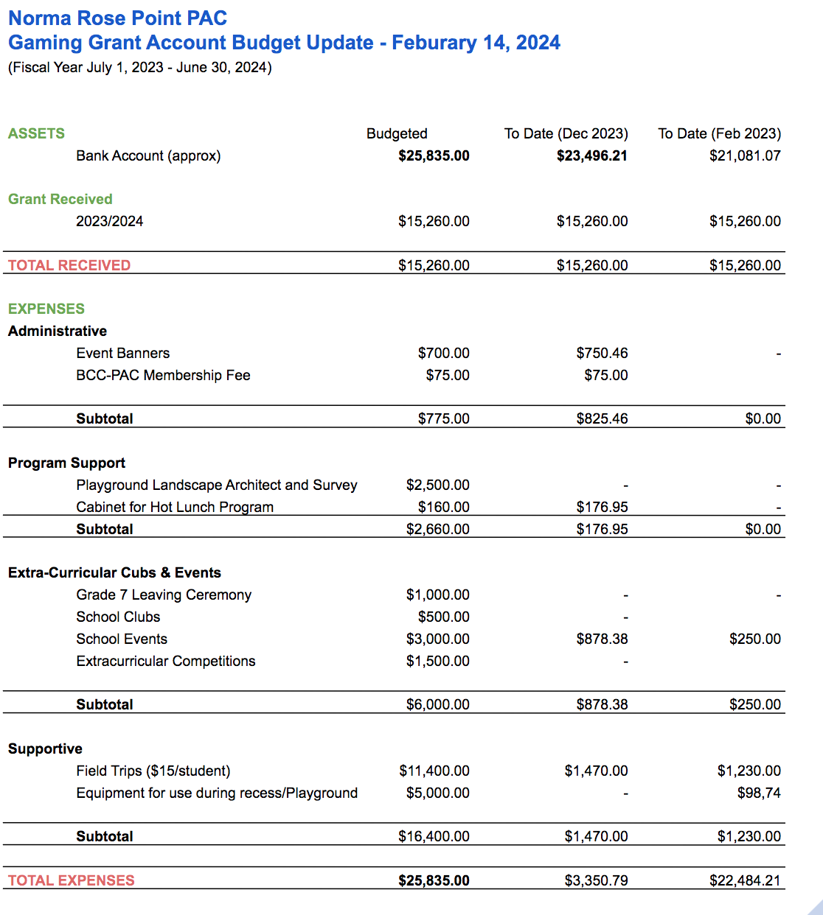

6. BUDGET ITEM APPROVAL
- Makedo tools: plastic tools for students to use safely on cardboard for construction.
- These will initially be used for Grade 7 students to make games for the Spring Fair.
- PAC and NRP will be purchasing sets of tools for the entire school to use.
- PAC contribution $500; $1,000 total, school pays for half.

MOTION: To spend $500 to purchase Makedo tools for the school.
MOVED: Karina; Seconded: Atul; All in favour, Carried.

7. UPCOMING EVENTS/PROGRAMS

MULTICULTURAL WEEK
• Week of February 26, 2024
• Special Guests:
- Welcoming Ceremony with Alec Dan, Musqueam on Monday, February 26
- Tae Kwon Do will be providing gym classes during PHE, and doing a performance during the week
- Piano performance representing Chinese culture
- K-pop group performing on Wednesday during lunch hour (primary and intermediate)
• Multicultural Day on March 1, 2024
o Cultures: Nigerian, Japanese, Spanish, Ukrainian, Persian, Chinese, Indian, Taiwanese
- Thank you, parents, for volunteering your time and sharing your cultures with the students!

2024 SPRING FAIR
- Friday, May 10 from 3 – 7pm
- More attractions, more community partners, more food!
- We need all hands-on deck! Volunteer opportunities will be made available by Spring Break.
- Lots of different volunteer opportunities; shorter shifts to be with your family and enjoy the Spring Fair.

8. T-SHIRT AND HOODIE SALE
- 264 Items Sold
- Raised $1106.26
- Ordered shirts/hoodies will be delivered to your child’s classroom

9. 2023 – 2024 YEARBOOK SALE
- Sold through School Cash Online – will be posted via School App this week
- Exciting changes:
o Option to purchase soft or hardcovers
o Increasing number of pages from 44 to 90+
o Changed companies from Jostens to Herff Jones
- Early Bird Sale:
o Soft Cover: $25
o Hard Cover: $35

10. NEW ITEMS

11. GENERAL Q & A

SUBSCRIBE TO NRP PAC POSTS
- https://nrprpac.ca
- Please let us know if you have any feedback on the website.

DOWNLOAD THE NRP APP
- Download on the App Store
- Get it on Google Play

UPCOMING PAC MEETINGS
- April 9, 2024 (In-Person)
- Interested in joining the PAC? Meet & chat with the current PAC Executive Committee Members!
- AGM: June 18, 2024 (In-Person)
- Voting for preliminary PAC Executive Committee

Next meeting: April 9, 2024 @ 6:30pm, In-Person
11. TERMINATION OF MEETING – 7:14PM
https://nrppac.ca | rosepointpac@gmail.com

