NRP PAC GENERAL MEETING MINUTES
October 17, 2023
6:30pm - 7:30pm
Zoom Conference Call
Call to Order: 6:31pm
Greeting and Land Acknowledgment: We would like to begin by acknowledging that the land on which we gather is the traditional, ancestral, and unceded territory of the xwməθkwəyə̓ m (Musqueam) People.

1. ADOPTION OF THE AGENDA

MOTION: To adopt the agenda for today’s meeting.
MOVED: Zeljka and Nicole; Seconded: Elena; All in favour, Carried.

2. APPROVAL OF PREVIOUS PAC MEETING MINUTES ON SEPTEMBER 19, 2023

MOTION: To approve the September 19, 2023 PAC Meeting Minutes.
MOVED: Martin; Seconded: Mila; All in favour, Carried.

3. NRP STAFF REPORT – PRINCIPAL, HENRY PETERS
- Land Acknowledgement.
- Volunteers are needed for the Book Fair next week, please see Ms. Izat.
- Response to the crisis in the Middle East: Each day as a school we stand against hatred, we stand against oppression. We stand against acts which marginalize individuals. We have a moral and ethical purpose to educate our students. At times messaging may be slow to come out; our silence is giving time to pause and gather thoughts and information and trying to communicate in a culturally sensitive way. NRP is trying to respond in a caring way. We do address subjects like violence and injustices every day in our teaching and learning even though this may not be communicated to parents. We invite you to reach out your child’s teacher or Principal. When we talk to each other we build community and understanding.
- Remembrance Day will be a formal assembly. The narrative may be shifted slightly to focus on peace and love, given the current global setting. The staff still hasn’t settled on this and will be meeting on this further. Once staff has settled on final details of the assembly, information will be circulated about parent attendance. Tentatively scheduled for November 10 after recess.
- Staffing: NRP tries to communicate leaves and absences while maintaining staff confidentiality. Staffing issues in K-3 wing have settled down a bit. There are currently a few divisions in the intermediate wing that are struggling with a shortage of staffing (not just continuous staffing but staffing at all).
- If a classroom teacher is absent and there is no Teacher on Call available, non-enrolling staff from within the school will be re-directed to cover.
- The impact of that there is a discontinuity of the teacher, the non-enrolling teacher is not able to work with their small support group, the non-enrolling teacher is no longer able to do their normal work load such as case management and student files.
- All of these teacher absences have a trickle-down effect. This impacts a teachers’ health and well-being as well as the entire school.
- NRP’s staff is amazing. SSAs are an amazing team that on the fly cover breaks, student groups and problem solve.
- We know that staffing issues affect students too. We appreciate your patience and understanding but we also understand your frustrations. Parents can reach out with their concerns as well.
- Thank you to everyone who attended Homecoming.

Book Fair – October 24 to 27 presented by Ms. Izat, Teacher Librarian
- Fundraiser for the Learning Commons
- Shopping hours will be before and after school: Tuesday (after school), Wednesday and Thursday (before/after school), Friday (before school).
- During school hours students will be able to preview books
- Volunteer sign-up link: https://signup.com/go/VicQkHV

4. NEIGHBOURHOOD CLIMATE ACTION PLAN presented by Kerry Shaw
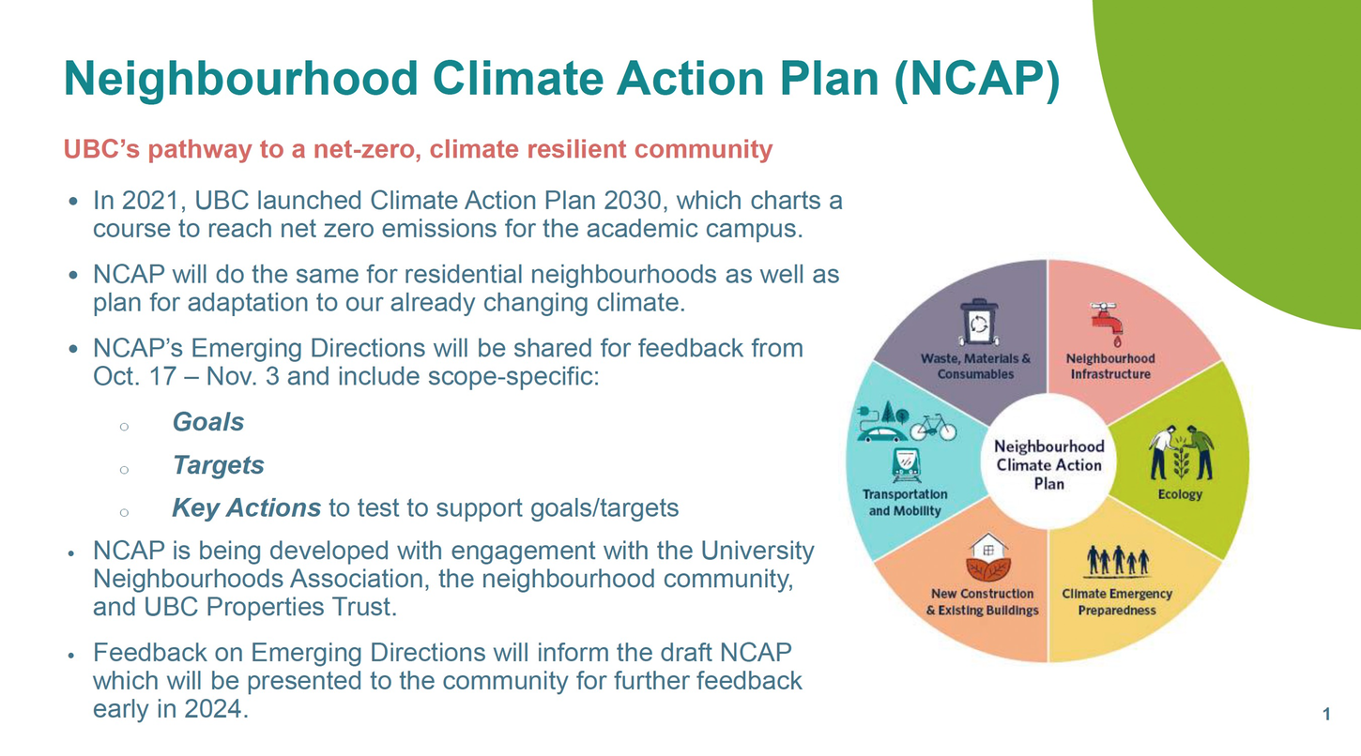

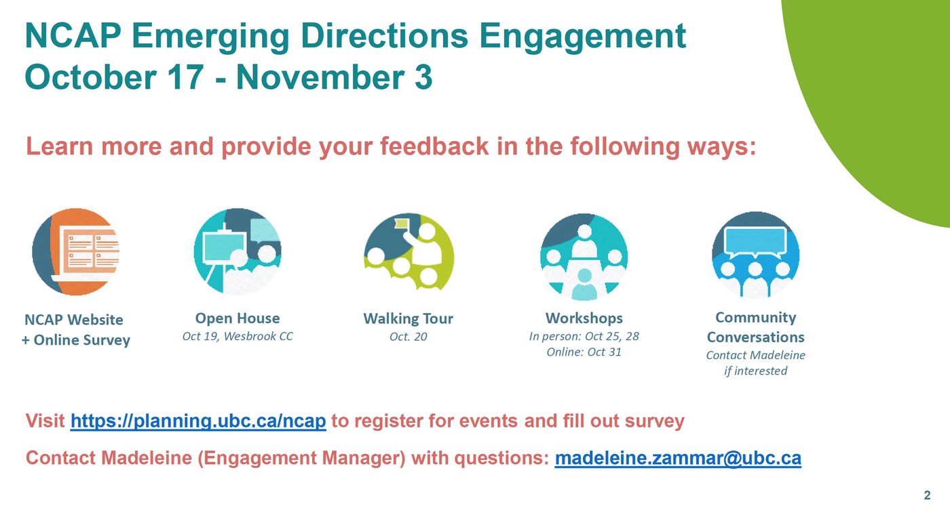

5. PAC EXECUTIVE COMMITTEE CHANGES

- Lydia C. has stepped out of the Event Coordinator role.

Looking for a NEW Treasurer - Email Hannie at nrppacchair@gmail.com
- Ensure all funds of the Council are properly accounted for
- Be a signing officer
- Ensure that proper financial records and books of account are maintained
- Make financial records and books of account available to members upon request
- Submit an annual financial statement at the AGM

6. PAC ANNUAL BUDGET CHANGES

Gaming Grant Changes/Updates
- Received $15,260 on October 4 to be used within 2 years since date received
- Playground Landscape Architect and Surveyor $2,500
- Events from $1,500 to $3,000
- Parent Education Workshops from $400 to $800
- Lunch Program Cabinet $160
- Field Trips from $10/student to $15/student
- Banners for the School $700
- Remove PAC Engagement Events

MOTION: To approve Gaming Grant budget changes.
MOVED: Kristen; Seconded: Nicole; All in favour, Carried.

Main Account Changes
- Body Science Workshop $1391.25
- Events from $1500 to $15,000
- Helping Hand from $1000 to $1500

Spring Fair
- Last year’s total expenses: $11,168 (note: $3700 was paid for entertainment and rides in 2020)
- Last year’s revenue: $14,361 (tickets, food, silent auction, food truck, donations) Average wait time for rides was 40-50 minutes
- Goals for this year: decrease ride wait times, increase food vendors, more community partners, more entertainment, more volunteers, track ticket sales and attendance

MOTION: To approve Main Account budget changes.
MOVED: Kristen; Seconded: Atul; All in favour, Carried.

Spring Fair 2024:
• Rides total of $7760.55
• Pay half now ($3880.28) by October 31
and receive 15% off the second half ($3298.24) for a total of $7178.52
- 2 Rides
- 2 Bouncy Castles - 1 Giant Slide
- 1 Obstacle course - 2 games

MOTION: To approve Spring Fair deposit for carnival rides (payment by Oct 31 to receive 15% off the second half payment).
MOVED: Kristen; Seconded: Omer; All in favour, Carried.

Join the Spring Fair Committee: Email us at rosepointpac@gmail.com

7. LUNCH PROGRAM VENDOR UPDATE
Libby’s Kitchen – Commercial kitchen for schools and daycares in the GVA | www.libbyskitchen.ca

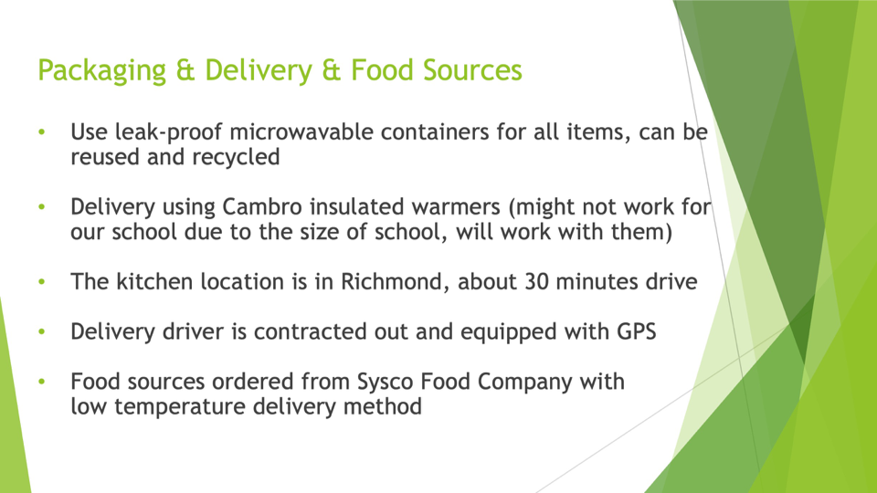

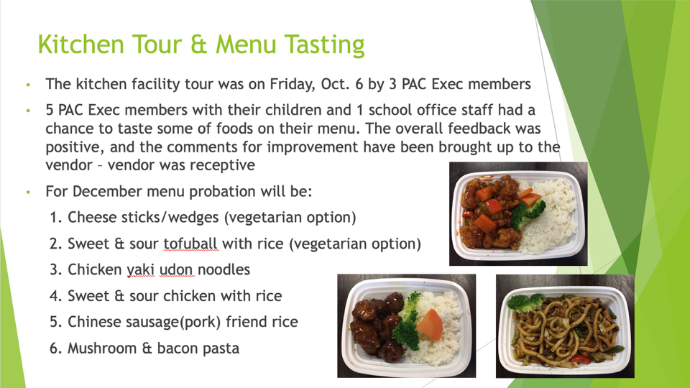
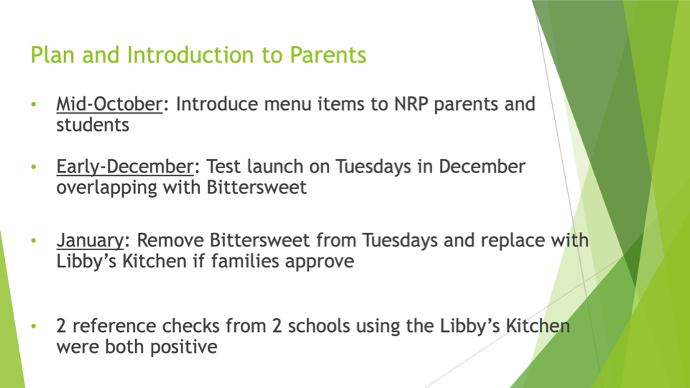

Thank you to Yawen, Lunch Coordinator for all her hard work vetting this vendor.

8. UPCOMING EVENTS/PROGRAMS PLANNED

Fresh to You Fundraiser
- All produce is locally grown in BC
- NRP receives 40% profit on all bundles
- Order deadline: Oct 20, 2023
- Delivery dates: Nov 15 – 25, 2023

Playground Update
Committee Members
Michelle Cheong
Kristen Haase
Annaick Carles
Alejandro Loyola
Tracy Elfring
Mark Sissons
Susan Font
Amer AbiRafeh

Phase 1: Planning
Step 1: Talk to Your Principal – Met with Mr. Peters earlier this month
Step 2: Form Your Team – Monthly meetings have been set
Step 3: Set Your Goals – Hope to break ground with Phase 1 by Summer 2024
Step 4: Fundraising – This will be phased work depending on fundraising.
Step 5: Get Inspired
Step 6: Know Your School
Step 7: Design Brainstorm
www.outdoorplaybook.ca

Homecoming Week Debrief
What Worked
• Big Gym was FULL
• Magic Show
• Pizza (had to buy more!) and drinks
• Class Posters

Improvements
• More pizza
• Better sound system
• Invite graduated Grade 7s from last year
• Grade 7 volunteers

Thank you to Cristina and Jake and all the volunteers for helping to make Homecoming a success!

9. NEW ITEMS

10. GENERAL Q&A

Q: Is there a dedicated teacher working with kids that need risk assessment? What would happen if a kid keeps on bullying others.
A: There are many contact points: Student Counsellor, Learning Support Teacher, Student Support Worker. There is a difference between unsafe behaviour and bullying. There are multiple touch points depending on who has a relationship with the student.

Q: Can you please provide more info regarding the upcoming body workshop next week and explain about the content that will be provided for each grade?
A: https://www.saleemanoon.com/workshops/body-science-at-school/

Q: With the recent burned down school in Port Coquitlam, has the school considered to do something to show support?
A: Perhaps the PAC can chat further about how we can support their PAC and how the students can show their support.

Upcoming PAC Meetings
December 19, 2023 (Zoom)
February 20, 2024 (Zoom)
April 9, 2024 (Zoom)
AGM: June 18, 2024 (In-Person)

SUBSCRIBE TO NRP PAC POSTS
- https://nrprpac.ca
- Please let us know if you have any feedback on the website.

DOWNLOAD THE NRP APP
- Download on the App Store
- Get it on Google Play

Next meeting: Tuesday, December 19, 2023 @ 6:30pm via ZOOM
11. TERMINATION OF MEETING – 7:35pm.
https://nrppac.ca | rosepointpac@gmail.com

