NRP PAC GENERAL MEETING MINUTES
September 19, 2023
6:30pm - 7:30pm
Learning Commons, NRP
Call to Order: 6:33 pm
Greeting and Land Acknowledgment: We would like to begin by acknowledging that the land on which we gather is the traditional, ancestral, and unceded territory of the xwməθkwəyə̓ m (Musqueam) People.

1. ADOPTION OF THE AGENDA

MOTION: To adopt the agenda for today’s meeting.
MOVED: Mark; Seconded: Jason; All in favour, Carried.

2. APPROVAL OF PREVIOUS PAC MEETING MINUTES ON JUNE 20, 2023

MOTION: To approve the June 20, 2023 PAC Meeting Minutes.
MOVED: Rejiv; Seconded: Mark; All in favour, Carried.

3. NRP STAFF REPORT – Principal, HENRY PETERS
- Welcome and thank you for attending this in-person PAC meeting.
- NRP is lucky to have facilities and experiences within school: two music teachers, applied skills/food classroom, and the forest all around the school.
- There are ongoing teaching changes in some communities, please be patient.
- Teachers do have responsibilities to communicate with parents. Please be respectful but conversations are important. We are all here for your children. Teachers are always your first line of communications, whether that be progress or concerns.
- There may be “anti-SOGI” protests on September 20. We hope this won’t be an issue at NRP but if it is, we will contact parents to get your children into the school safely.
- Open House “Meet the Teachers” are planned for September 21. Teachers will communicate times to visit your child’s community. This is not a chance to discuss your child specifically.
- Parent-Teacher Conferences will happen in October. First report cards come out December 1.
- If ALL the school doors are all locked at the end of the school day and there is an earthquake drill, please proceed to the meeting spot on the gravel field.
- NRP welcomes Vice Principal Julia Clark, who is new to NRP this year.
- There is a teacher shortage this year; location plays a factor at NRP as many teachers have to commute to NRP. We are asking for your patience as we navigate any staffing issues.

Q: Is it possible to increase the time for lunch, in the primary wing?
A: This is a balancing act; sometimes 20 minutes is too long for some and too short for some. We try and support students who need more time to eat during instructional time.

Q: Would a car line be beneficial for drop-off in the morning?
A: The car issue is problematic. I would be open to working with a group of parents or with signage to implement a strategy to help alleviate this pressure.

Q: How are children assigned to classes with split grades?
A: Kindergarten is the only grade that cannot be split. For other divisions you look at needs, friendships and make equitable classes. Children who require additional support are also considered.

4. PAC EXECUTIVE COMMITTEE CHANGES

NAME | POSITION
Hannie Chia | Chair
Yuki Namekawa | Past Chair
Mitsue Kawashima | Treasurer
Michelle Cheong | Secretary
Jake Raynard | Co-Event Coordinator
Lydia Cecilia | Co-Event Coordinator
Cristina Schaurich | Co-Event Coordinator
YaWen Ho | Lunch Coordinator
Donna Zhou | Lunch Volunteer Coordinator
Brandon Trajano | VSB DPAC Representative
Nicole Kraumanis | Parent Education Coordinator
Wendy Lei | Member at Large
Atul Gadhia | Member at Large
Rejiv Menon | Member at Large
Kristen Haase | Member at Large
Athary Ja | Member at Large

MOTION: To elect the above 2023 – 2034 PAC Executive Committee.
MOVED: Jason; Seconded: Natalie; All in favour, Carried.

5. PAC ANNUAL BUDGET PROPOSAL

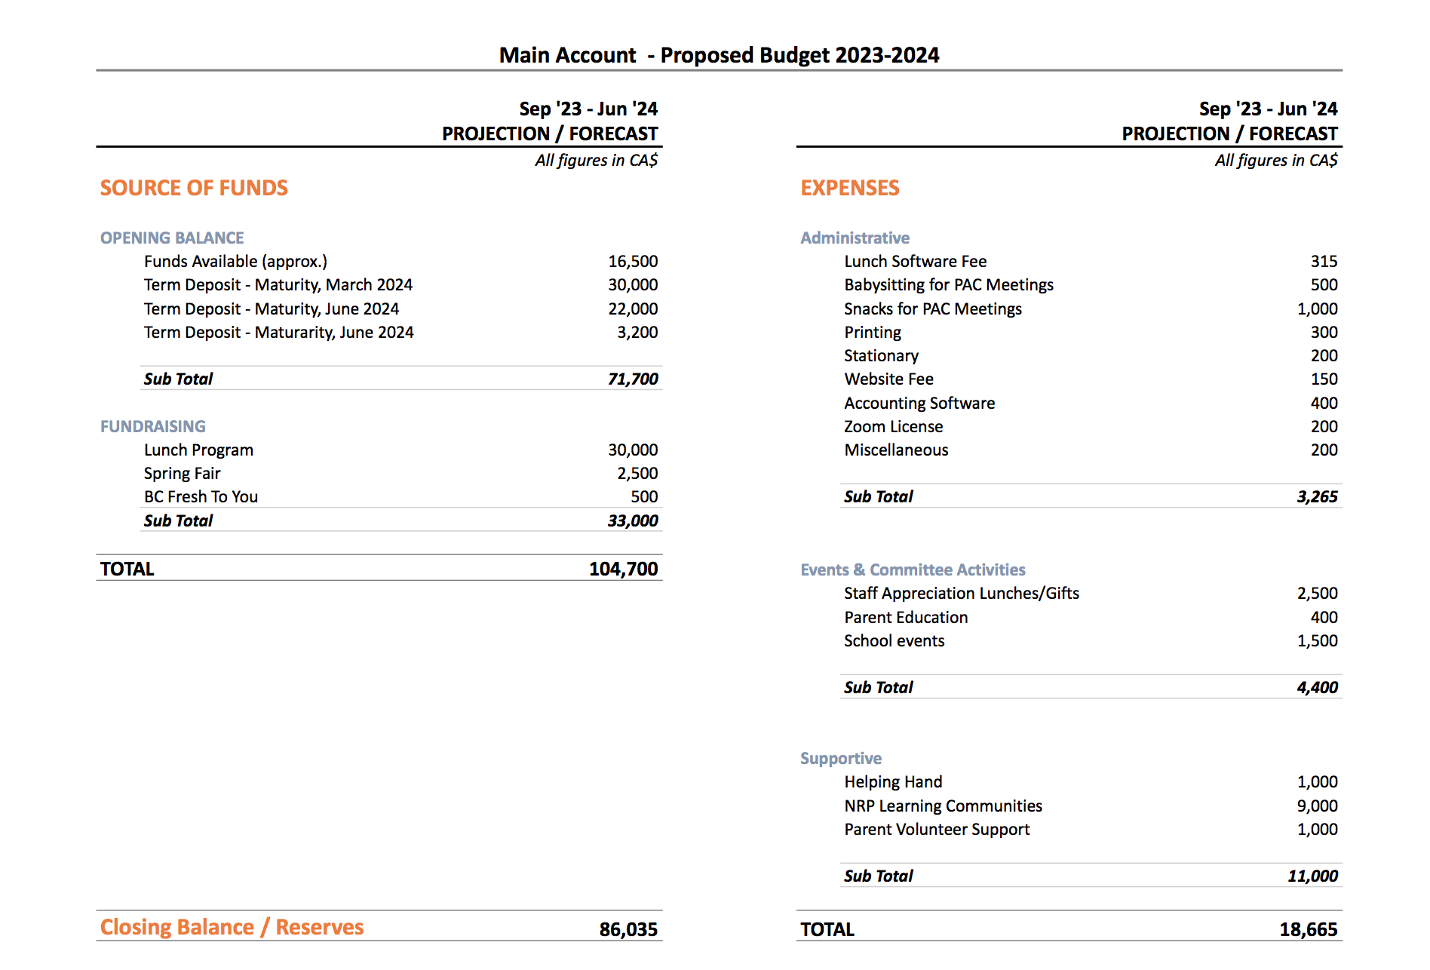

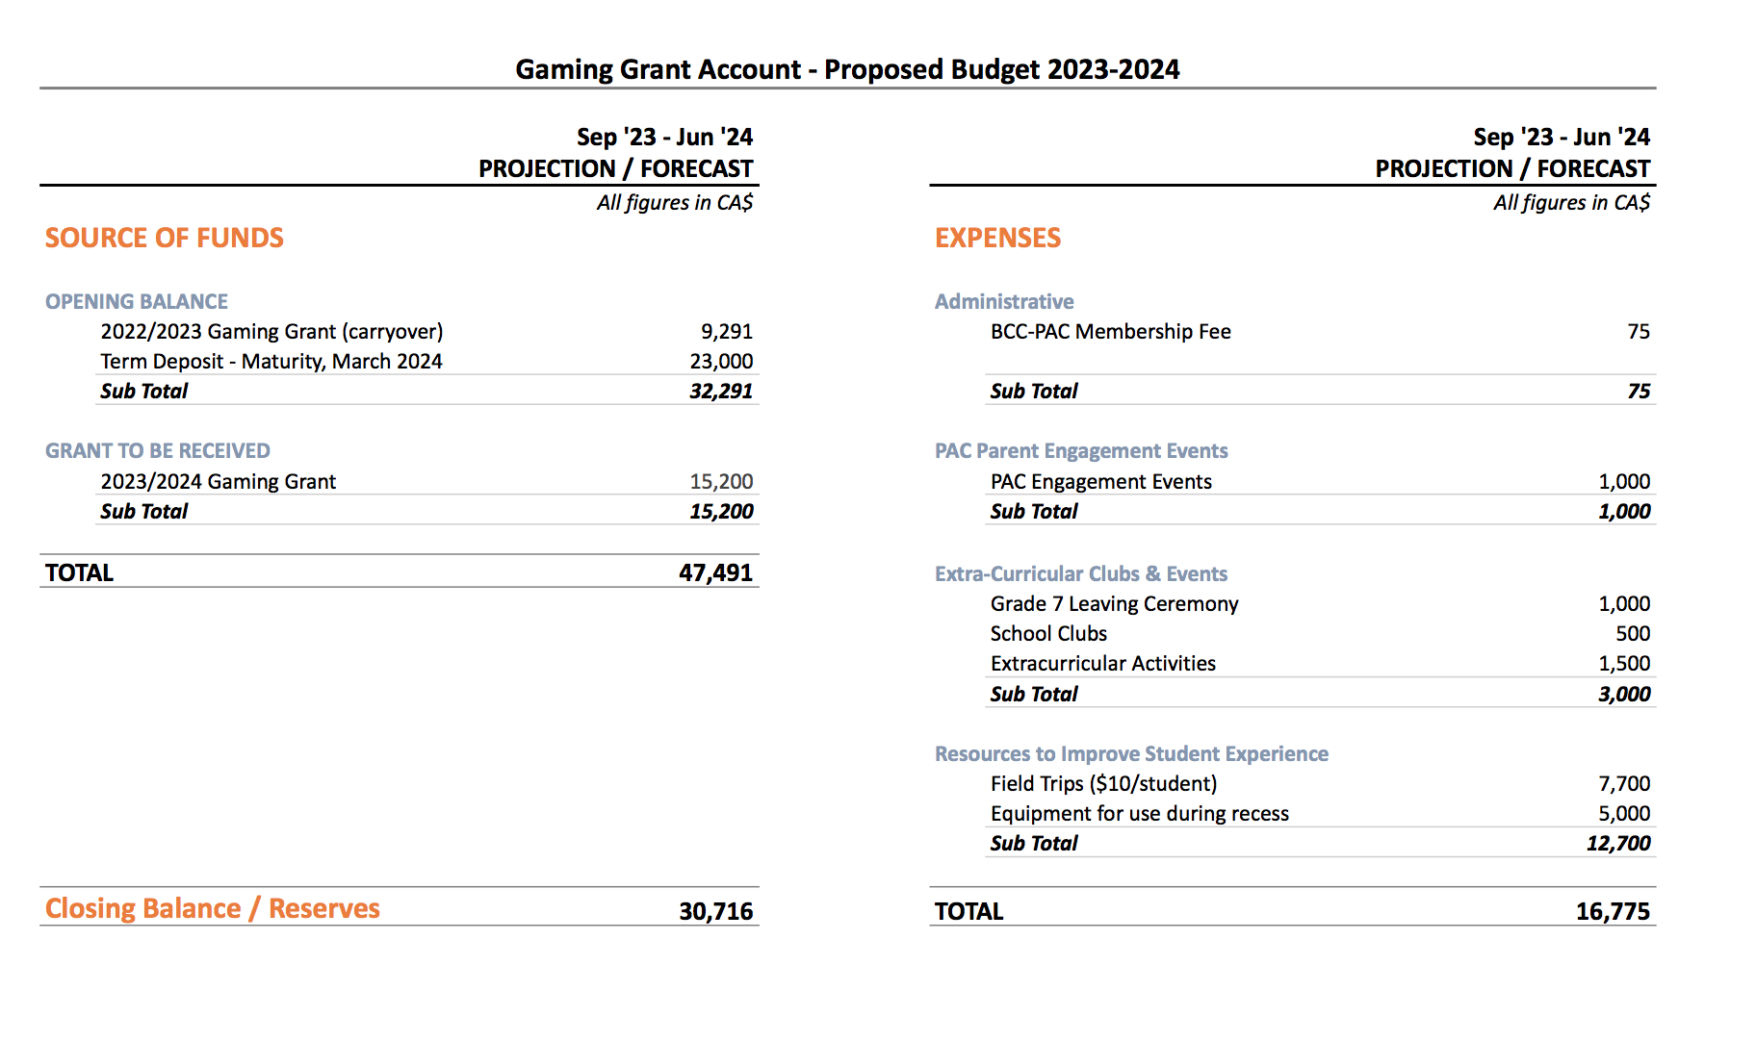
-Presented by PAC Chair, Hannie. Spoke about changes in budget from previous year, ie. Increases of certain line items.

Q: Have things been cut due to increases?
A: No, a lot of items are covered by government funding and other fundraising efforts.

Q: What’s is the status of the new playground?
A: The playground is currently in the planning stage. Any questions about the playground or the playground committee can be directed to rosepointpac@gmail.com

MOTION: To approve the 2023 – 2034 proposed budget.
MOVED: Anthony; Seconded: Zamara; All in favour, Carried.

6. PROGRAMS PLANNED
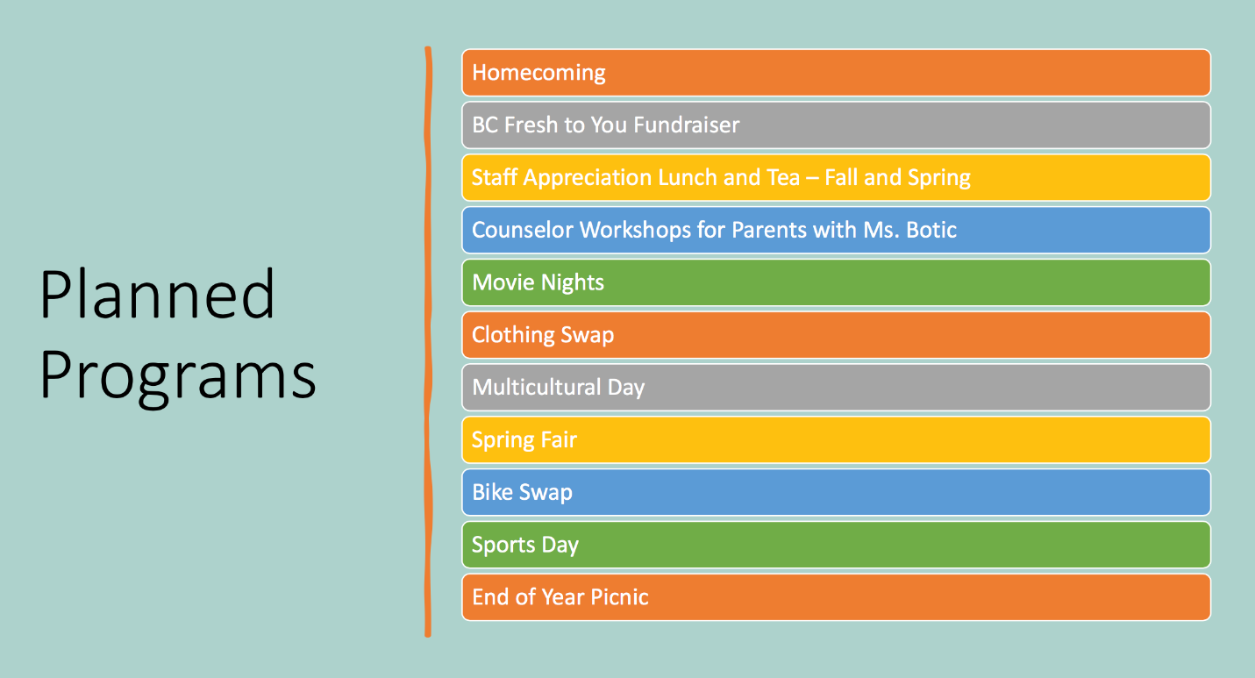
- Presented by NRP Chair, Hannie

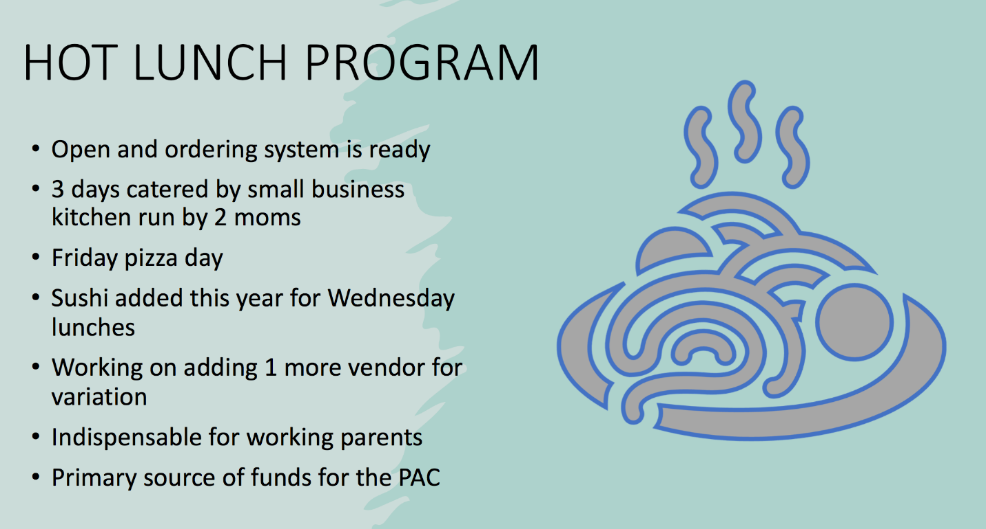
-Presented by NRP Chair, Hannie

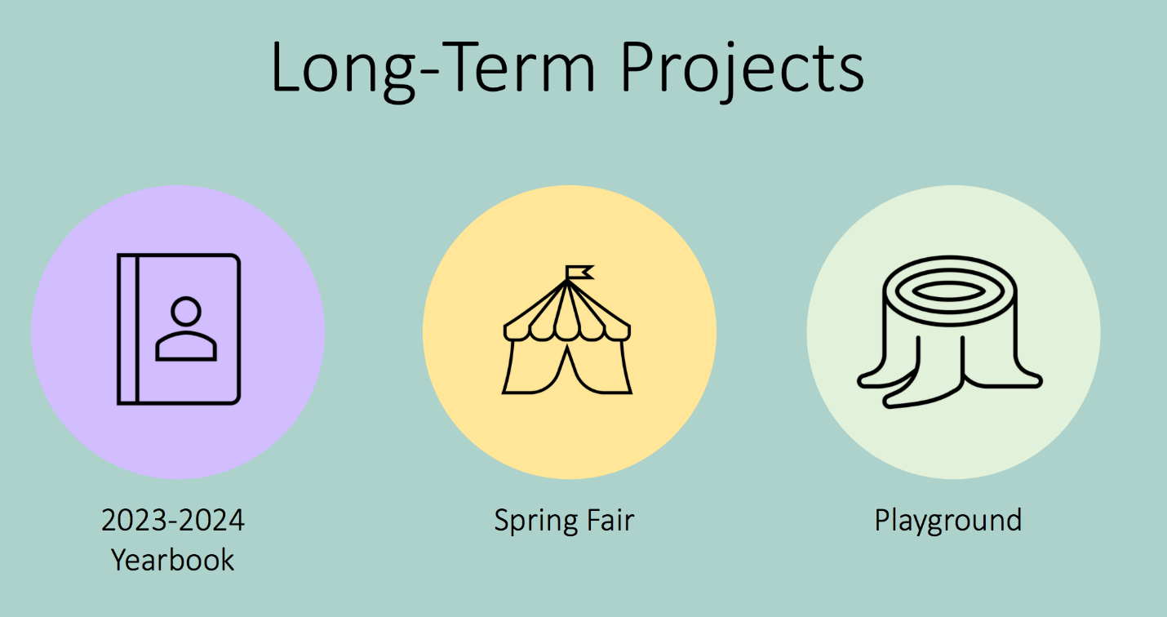
-Presented by NRP Chair, Hannie
-Changes to Yearbook format from hardcover to softcover, this will allow for more pages.

Playground Update
- Contact: rosepointpac@gmail.com

Upcoming PAC Meetings
October 17, 2023 (Zoom)
December 19, 2023 (Zoom)
February 20, 2024 (Zoom)
April 9, 2024 (Zoom)
AGM: June 18, 2024 (In-Person)

SUBSCRIBE TO NRP PAC POSTS
- https://nrprpac.ca
- Please let us know if you have any feedback on the website.

DOWNLOAD THE NRP APP
- Download on the App Store
- Get it on Google Play

Next meeting: Tuesday, October 17, 2023 @ 6:30pm via ZOOM
11. TERMINATION OF MEETING – @7:25pm.
https://nrppac.ca rosepointpac@gmail.com

