NRP PAC GENERAL MEETING MINUTES
June 20, 2023
6:30pm - 7:30pm
Learning Commons, NRP
Call to Order: 6:40pm
Greeting and Land Acknowledgment: We would like to begin by acknowledging that the land on which we gather is the traditional, ancestral, and unceded territory of the xwməθkwəyə̓ m (Musqueam) People.

1. ADOPTION OF THE AGENDA

MOTION: To adopt the agenda for today’s meeting.
MOVED: Atul; Seconded: Brandon; All in favour, Carried.

2. APPROVAL OF PREVIOUS PAC MEETING MINUTES ON MAY 16, 2023

MOTION: To approve the May 16, 2023 PAC Meeting Minutes.
MOVED: Brandon; Seconded: Katy; All in favour, Carried.

3. NRP STAFF REPORT – Principal, HENRY PETERS; Vice Principal, ANDREA GREENHALGH
- June 21: National Indigenous Peoples Day.
- First Peoples Principles of Learning Raingarden: Water is a gift. There has been wonderful work taking place in the raingarden with Lisa Nordman, our Project Teacher.
- We have been working hard on class casting. It is an intensive, complicated process. Each day a different grade is being worked on. There will be a lot of movement in the summer.
- There are at least 20 staff that are moving on. NRP is geographically far away and this can create staffing pressure. VP Greenhalgh is moving on to another school.
- Ministry of Education has put out new guidelines on reporting and report cards. NRP will reach out to parents on their thoughts on what parents would like to see on report cards in regards to growth.

Q: Reporting – is there a benchmark or average for a child and for a class as a whole so that we can see where our children are academically, and also so that a teacher can see where the class stands in relation to grade averages?
A: Reporting in the past has moved to conversational reporting and to qualitative vs. quantitative. There is a move back now to a slightly more quantitative approach.

Q: How will teachers help Kindergarteners adjust to a community that will have Grades 1-3 next year?
A: In communities where there is a range of grades, there is a leadership model with expectations and routines. We also need to physically put students into the classroom spaces that we have.

Ms. Greenhalgh
- Thank you and Goodbye!
- Ms. Clark will be the incoming VP, coming from Lord Kitchener. She been with the VSB over 20 years.

4. PAC EXECUTIVE COMMITTEE ELECTION

NAME | POSITION
Hannie Chia | Chair
Yuki Namekawa | Past Chair
Mitsue Kawashima | Co-Treasurer
Donna Zhou | Co-Treasurer
Michelle Cheong | Secretary
Jake Raynard | Co-Event Coordinator
Lydia Cecilia | Co-Event Coordinator
Cristina Schaurich | Co-Event Coordinator
YaWen Ho | Lunch Coordinator
Lan Zhu* | Lunch Volunteer Coordinator
Brandon Trajano | VSB DPAC Representative
Wendy Lei | Member at Large
Atul Gadhia | Member at Large
Rejiv Menon | Member at Large
Kristen Haase | Member at Large
Athary Ja | Member at Large
*To be voted in next PAC General meeting

MOTION: To elect the above 2023 – 2034 PAC Executive Committee.
MOVED: Katy; Seconded: Karina; All in favour, Carried.

5. MOTION TO REMOVE PAC BYLAW

MOTION: To remove PAC Bylaw 4.9 Any Unfilled Executive Positions (as defined above in Section 4.2) shall be filled no more than sixty (60) days after the Annual General Meeting.
MOVED: Michelle; Seconded: Atul, Brandon; All in favour, Carried.

6. PAC ANNUAL REPORT

Hot Lunch Program
• Restarted in fall of 2021
• 3 days catered by small business kitchen run by 2 moms
• Friday pizza day
• Sushi added this year for Wednesday lunches
• Indispensable for working parents
• Primary source of funds for the PAC

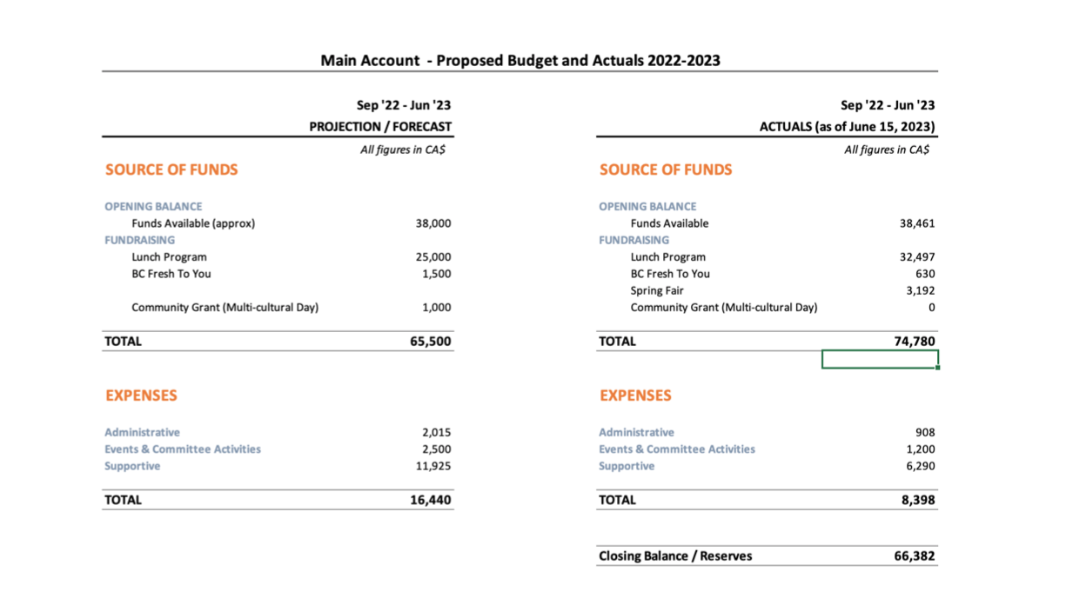
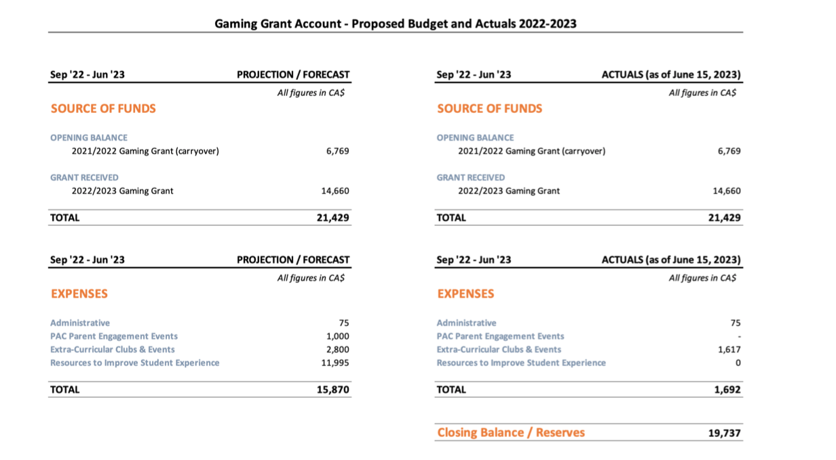
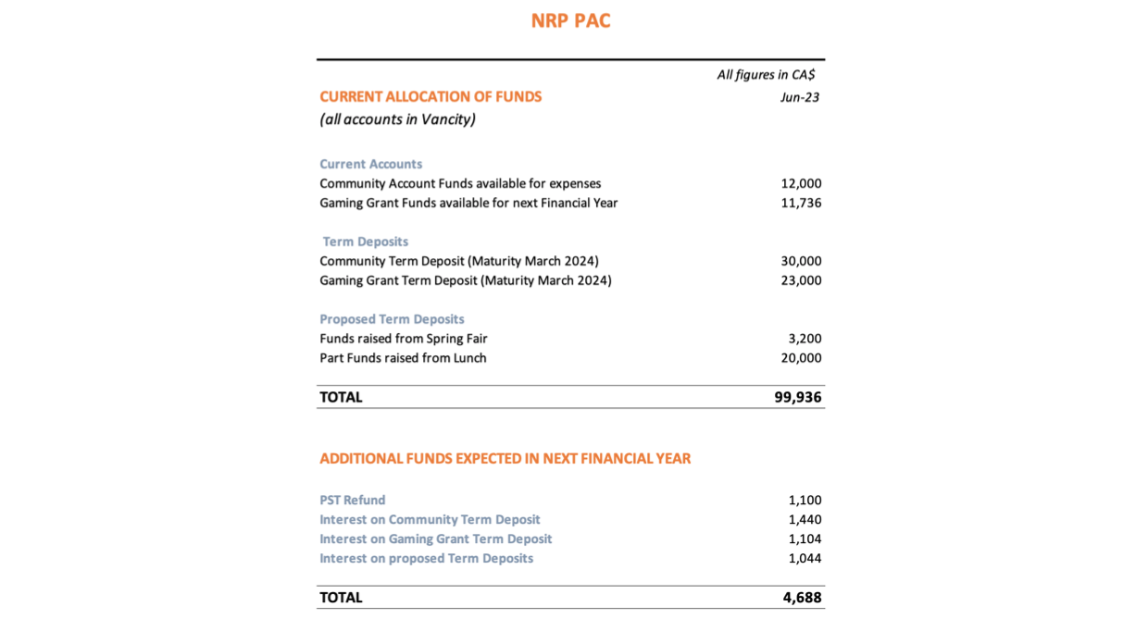

7. EVENTS

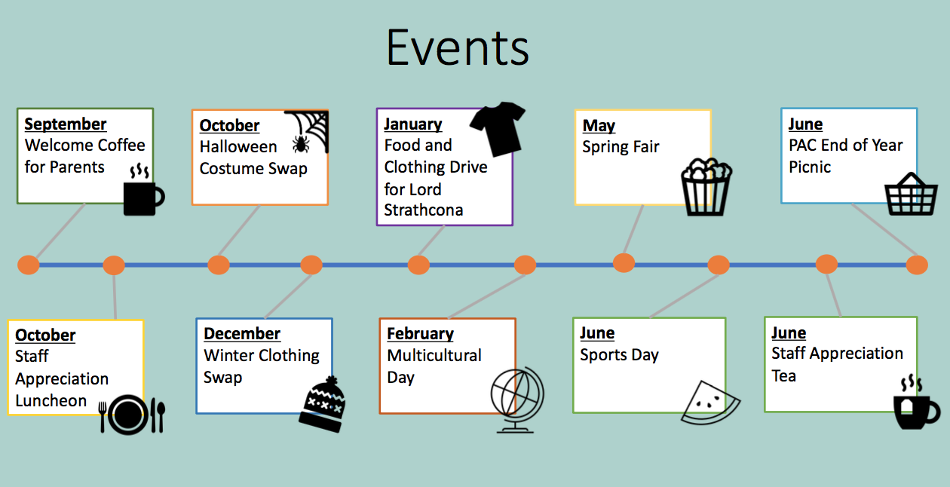

8. LONG-TERM PROJECTS

- 2022-2023 YEARBOOK

- FIRST PEOPLES PRINCIPLES OF LEARNING RAINGARDEN

- PLAYGROUND
9. NRP PLAYGROUND SURVEY

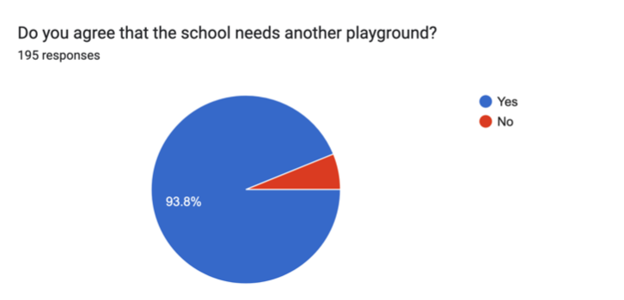

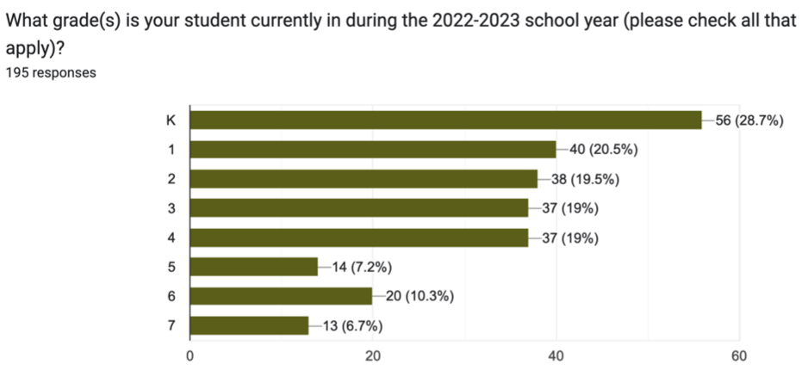

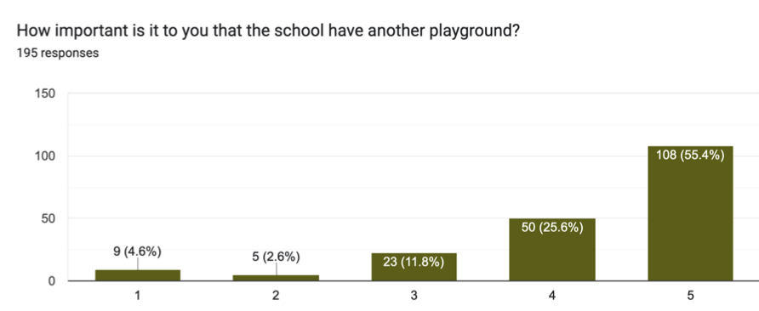
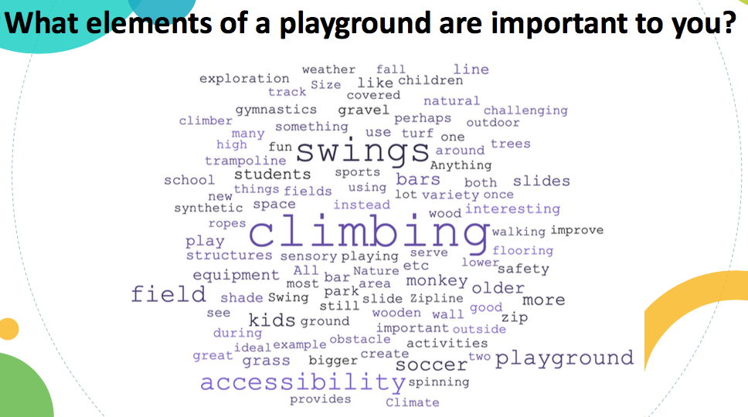

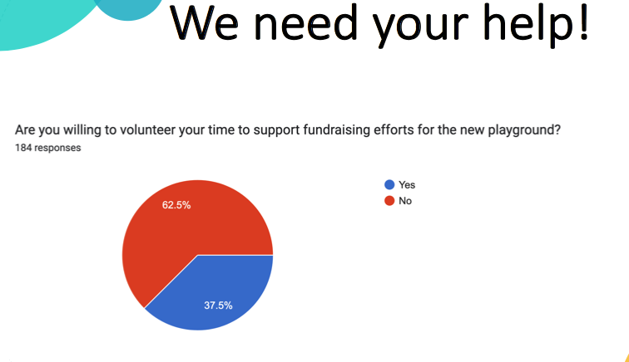

We hope to get a planning committee underway in September. If you like to volunteer with playground planning, please email nrppacchair@gmail.com.

10. ADDITIONAL ITEMS

END OF YEAR PICNIC
Friday, June 23, 3:00 – 5:00pm
BYO Picnic and Picnic Blanket
Official Unveiling of the First Peoples Principles of Learning Raingarden
- PAC needs volunteers to hand out Timbits as “afterschool snack”. Please sign-up!

STAFF APPRECIATION TEA – Thank you to everyone who contributed!

Next School Year
- More light touch events – movie nights and parent workshops
- More parent/guardian volunteer opportunities
- In-Person PAC meetings – phasing out Zoom meetings

SUBSCRIBE TO NRP PAC POSTS
- https://nrprpac.ca
- Please let us know if you have any feedback on the website.

DOWNLOAD THE NRP APP
- Download on the App Store
- Get it on Google Play

Next meeting: Tuesday, September 19, 2023 @ 6:30pm (Every 3rd Tuesday of the Month) IN PERSON
11. TERMINATION OF MEETING – 7:40pm

