NRP PAC GENERAL MEETING AGENDA
October 18, 2022
6:30pm - 7:30pm
via Zoom Meeting
Join Zoom Meeting
https://us02web.zoom.us/j/82234143912?pwd=dk9VRWFaeGtabmthV1BpR2hHenBYUT09
Meeting ID: 822 3414 3912
Passcode: 380442
Call to Order: 6:32pm
Greeting: We would like to begin by acknowledging that the land on which we gather is the traditional, ancestral, and unceded territory of the xwməθkwəyə̓ m (Musqueam) People.

1. APPROVAL OF PREVIOUS PAC MEETING MINUTES ON SEPTEMBER 20, 2022
MOTION: To approve the September 20, 2022 PAC Meeting Minutes.
MOVED: Hannie, Seconded: Taniya, All in favour, Carried.
2. ADOPTION OF THE AGENDA
MOVED: Hannie, Seconded: Taniya, All in favour, Carried.
3. ELECTING THE EXECUTIVE PAC TEAM FOR THE 2022/2023 SCHOOL YEAR
*If anyone is interested in joining the PAC Executive Team for any of the vacant positions, please email rosepointpac@gmail.com.

MOTION: To elect the Executive PAC Team for the 2022/2023 school year.
MOVED: Heather T., Seconded: Paulina S., All in favour, Carried.
POSITION IN 2022/2023 | CANDIDIATE
Chair / Co-Chair | Hannie Chia / Yuki Namekawa
Treasurer/ Co-Treasurer | Taniya Amiraj
Secretary | Michelle Cheong
Volunteer Coordinator | Donna Zhou
Parents Education | Vacant
Communications/ Social Media | Vacant
Lunch Program Coordinator | Taniya Amiraj
Events | Leticia Esponda (until January ‘23), Tanita Puangbanbut, Paulina Vargas
Fundraising | Vacant
DPAC Representative | Sean Feng and Rejiv Menon
Member-at-Large | Atul Gahdia, Wendy Lei, Kristen Haase, Henry Mao

4. NRP STAFF REPORT – VP, ANDREA GREENHALGH
- Mr. Peter sends his regards. He will be back as soon as he can.
- NRP held its first live performance in almost 3 years: “Ache Brasil”. All 765 students were in the large gym. Kids enjoyed themselves.
- Several more performances have been booked for the rest of the school year. Most will now be split for primary and intermediate students based on target audience. Some you will hear about beforehand, some you hear about after.
- The next performance is scheduled for the end of the month called Planet Protectors for Grades 1 – 4. It is run by the City of Vancouver Recycling Team.
- Planning for Remembrance Day Assembly is underway. It will be split by primary and intermediate grades.
- NRP has had a very successful Cross Country season. Thanks to all the teachers who are coaching: Mr. Beale, Chef Smith, and Ms. Hunt. There are approximately 75 students involved in Cross Country. This Thursday is the District meet where upwards of 5,000 students will be racing at Trout Lake. It is the largest single event that VSB puts on for students.
- Soccer, coached by Chef Smith and Ms. Chohan, has been playing at Kerrisdale Elementary. They are a very dedicated but small team. They are wrapping up their season in the next couple of weeks.
- Volleyball team is starting coached by Ms. Eng.
- Library monitors have been trained by Ms. Izat.
- Lunch Buddies program, where Grade 6/7 eat their lunch with the primary students, is running.

Health and Safety:
- School Safety Patrol (Grade 6/7) has started at the crosswalk at Ortona and Acadia Rd. They were trained by a Constable at the VPD alongside Ms. Greenhalgh. The schedules have been created and they will be in operation. Thank you to everyone who has been thanking them for their work.
- Please walk your bikes and scooters while on school grounds. There have been near misses of bikes and scooters and pedestrians.

Traffic:
- RCMP has been out visiting.
- There have been a lot of complaints about the pick-up/drop-off areas.
- A lot of families are heading into the staff parking lot on the east-side of the school and using it as a drop-off/pick-up location. NRP is going to start coning this area off. This is not a pick-up/drop-off spot. There are staff members who have to leave the school grounds and need access to the parking lot. Students are running across the parking lot and this is not safe. If you are looking for an alternative pick-up/drop-off spot, please consider crossing the gravel field behind the school and using the St. Anslem’s church parking lot – please also proceed with caution as there is a preschool program that uses that parking lot and there are small children nearby.

Staff Report:
- Lisa Nordman is NRP’s new Project Teacher. She is focusing on a Musqueam teaching kit, that was designed and written with Musqueam elders and the Musqueam education team through the Museum of Anthropology. There is a lot of interest from the classes and we are fortunate to have this educational opportunity.

- As Halloween gets closer, each community will be reaching out with guidelines about how they would like to “celebrate” Halloween. In terms of snacks, NRP is still requesting no homemade snacks. Everything must still be individually wrapped. Teachers will communicate with families as to what will happen over Halloween.
- An NRP school newsletter will be released in the next few days.
- Direct Appeal will be released in the coming weeks. This is a fundraiser for the school and is tax deductible through the school board.

Q+A

Q: Why were Kindergarten students not invited for the Cross Country team?
A: It is a District policy for safety. In some schools, Kindergarteners may be invited to practice but they are not allowed to participate in any meets, especially the Trout Lake meet as it is very overwhelming with so many students participating.

Q: Could you share the VSB Policy about air pollution if not today, in the next meeting or newsletter?
A: NRP takes direction from Vancouver Coastal Health and Provincial Health Authority. VCH and PHA monitors particulate matter every single day and unless they contact us they don’t deem it a threat for elementary-aged students. In the past, they have contacted us but they have not alerted us this time around.

Q: Could students ask their teachers to stay inside if they are concerned with the air quality?
A: Students cannot be inside unsupervised. If there is a teacher inside their community that is available to supervise the students than they may offer but it is up to the teacher to offer.

Q: Will the Grade 3 students have music with Ms. Tamara this year?
A: It changes each year. Not all Grade 3 students will have music with Ms. Tamara, and not all will have foods with Chef Smith. They try and balance it out so that no community misses it for two years in a row.

Q: Could we learn a bit more about the plans for a playground construction/resources for the children in grades five and up, please? Some kids are not keen on soccer or basketball, and await (wish for) a playground structure to clamber on and enjoy.
A (from PAC): As a PAC we are currently working on an Indigenous Garden. We would also like to work on a playground construction as well for the older students. We would like to form a playground committee. If you are interested in joining the committee, please email us at rosepointpac@gmail.com.

Q: Are they going to have nature school in Pacific Spirit Park as a part of their weekly program? It connects them to the land and also emergent curriculum for teachers, beside physical activities.
A: I believe the answer is yes. There are already many classes that are in the forest on a weekly basis. It also depends on the class, when they are ready and what they are studying.

Q: Could you provide an update on the shooting incident that happened yesterday at the UBC Golf Course, as well as lockdown drills at NRP?
A: Just as NRP has fire drills and earthquake drills, shelter in place drills and lockdown drills serve a function. They are all practiced throughout the year. There is a schedule on when and how often they are practiced. With the shooting, NRP had confirmation from the RCMP in person and over the phone that there absolutely was no threat to the public and we could continue on with our day. The staff were notified at lunchtime prior to the end of lunch hour in case any of the older students returned from lunch with information. Thankfully, this wasn’t the case. At the time of the shooting, there were no classes outside.

There are only two sets of doors that are unlocked from the outside during school hours: the main office doors and the ones directly across by the sundial. If you are late for school, you need to sign in at the office. Please only enter through those doors. The other doors are locked for safety reasons.

Q: Is there a policy regarding how -- or if -- teachers communicate content the children are being taught to parents? Is it expected that some sharing should occur through a newsletter; weekly; or bi-weekly email?
A: There is no policy. Some teachers communicate with parents via email. Some students write in their home journals. Some teachers have casual conversations at pick-up. There are 5 points of communication throughout the year: two are report cards and three are conferences.

5. FINANCIAL REPORT – TANIYA AMIRAJ
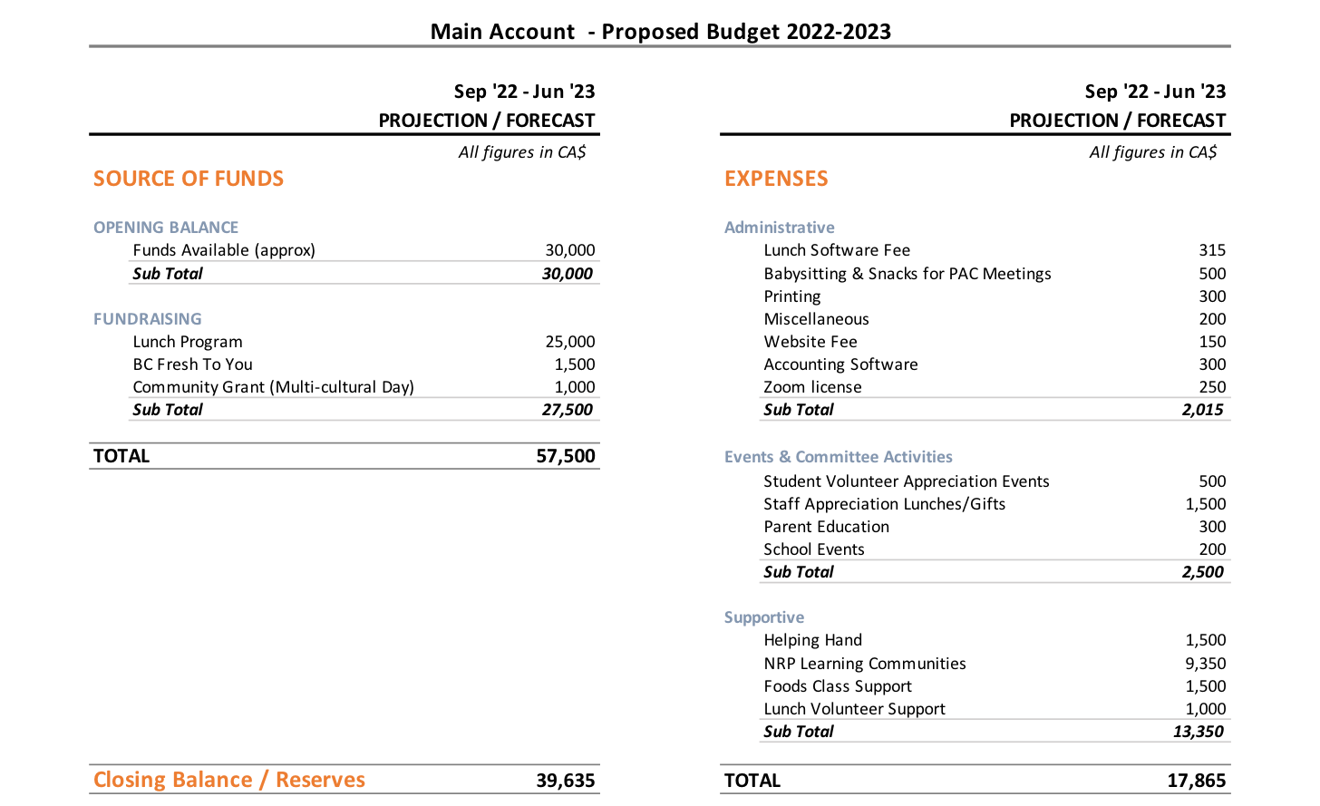
- Majority of the “Opening Balance” funds were primarily raised through the Lunch Program last year.
- For those that were not at NRP last year, Multi-Cultural Day is an event that we run once a year where families from different countries are invited to set-up a booth and showcase their cultures through performances or activities.
- Helping Hands is an initiative where PAC supports any families that require financial support through the school.
- NRP Learning Communities provides teachers with $200 for classroom supplies.
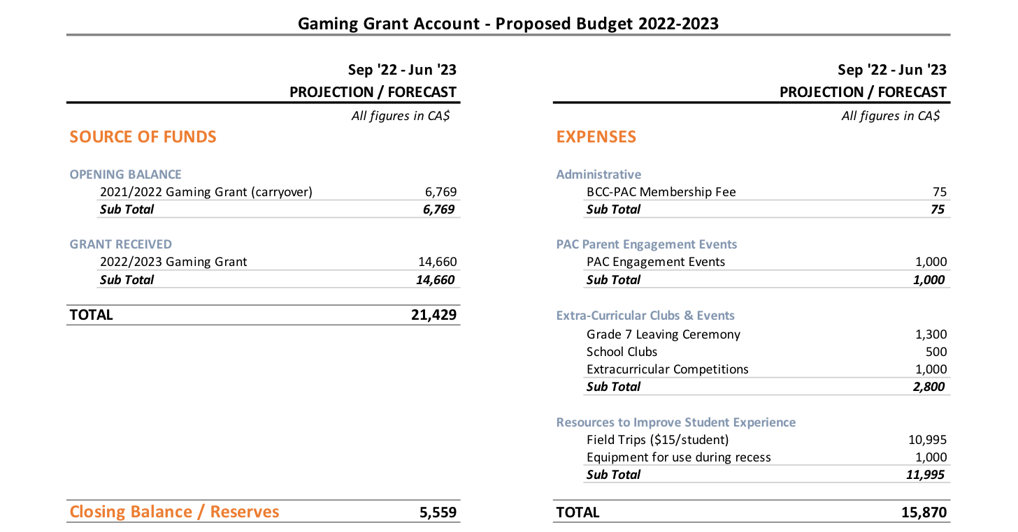

- The Gaming Grant is a grant given by the BC Government. The PAC applies for it every year and this year our application was accepted. The grant can only be used for extra-curricular activities to support the school.

6. MOTION TO APPROVE THE 2022/2023 PROPOSED BUDGET
MOTION: To approve the 2022/2023 proposed budget.
MOVED: Kristen, Seconded: Rejiv, All in favour, Carried.

7. MOTION TO APPROVE PAC EXECUTIVES TO SIGN CHEQUES FOR UP TO $5,000 FOR ANY VENDORS OR FUNDRAISING ACTIVITIES.
MOTION: To approve PAC Executives to sign cheques for up to $5,000 for any vendors or fundraising activities.
MOVED: Kaitlyn R., Seconded: Michelle, All in favour, Carried.

8. UPCOMING EVENTS & FUNDRAISERS

HALLOWEEN COSTUME SWAP PARTY
Swap your gently used costumes that no longer fit and get something new just in time for Halloween!
- Costume drop off:
October 19 + 20, 8:30 – 9:30am, Outside the Multipurpose Room

- Costume Swap Party
Monday, October 24, 3:15 – 4:00pm, Indoor Foyer, next to the Library

TEACHER AND STAFF APPRECIATION LUNCH – OCTOBER 25, 2022
We need your help to raise our goal of $950 to treat over 70 staff members lunch by October 20, 2022.

Please send donations to: nrppacfundraising@gmail.com and include in the note your name or anonymous, and “Staff Appreciation Lunch Donation”.

FRESH TO YOU FUNDRAISER
Order produce locally grown from BC suppliers by October 23, 2022. Two bundles of produce are available to purchase.
Form: https://forms.gle/UZCBAy7CsL5NcWhUA

NRP receives 40% profit on all of the bundles sold, and 100% of the profit will go directly to the NRP Foods Program.

SPRING FAIR (PREVIEW)
Save the Date: Friday, May 5, after school
Highlights: Musical acts, ticketed carnival rides, food stand/trucks, silent auction, and more.
Ask: We need volunteers! Please email: nrppacevents@gmail.com
- We will be opening this event to other UBC children and families (UHill elementary school, UHill secondary).

KINDERGARTENERS NEED BOOKS
Please drop off your donations in front of the Multipurpose Room (indoors) in a cardboard box labeled Kindergarten Book Donations. Donations will be accepted until Thursday, October 20, 2022.

9. VOLUNTEER OPPORTUNITIES
- Food Class: Contact Chef Smith at kssmith@vsb.bc.ca
- Yearbook Committee: Contact Yearbook Committee at rosepointyearbook@gmail.com

10. ADDITIONAL ITEMS

BULLYING STOPS HERE
- During the last meeting the topic of bullying was brought up. The PAC Co-Chairs discussed this topic with VP Greenhalgh. The school and PAC Executives are working together on bringing in an expert to present and discuss on the subject. If anyone in the community has any information that they would like to share on this topic or if they know a speaker that would be appropriate, please reach out to the PAC. In the meantime, Ms. Greenhalgh and the school are working on finding a speaker.

DOWNLOAD THE NRP APP
- Download on the App Store
- Get it on Google Play
- Subscribe to NRP PAC Posts: https: nrprpac.ca, scroll to the bottom of the page.

LUNCH PROGRAM
Absent/Cancellation policy – listed on the PAC website
- You may cancel your order Monday of the week prior to your lunch order online
- Order cannot be stored for pick-up later for health and safety reasons

Next meeting: Tuesday November 15 @ 6:30pm (Every 3rd Tuesday)

9. TERMINATION OF MEETING – 7:25pm

