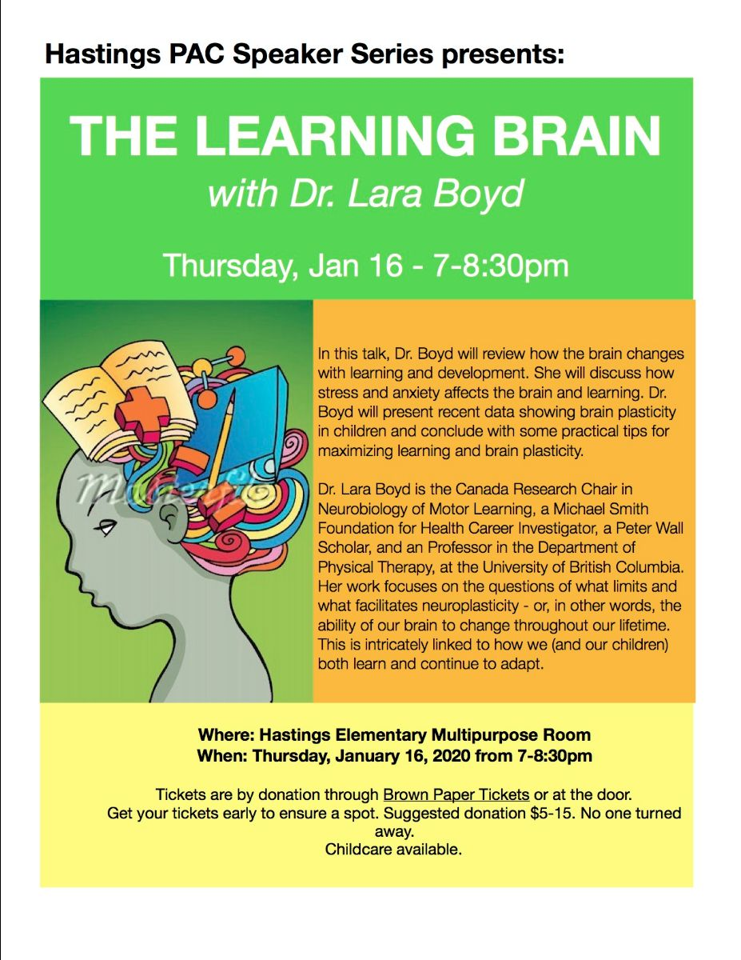
GET TICKETS HERE
https://www.brownpapertickets.com/event/4475037

