2018-19 NRPS PAC Parent Education Committee
Friday, December 14, 2018
Please join at www.slido.com
with this code: #NRPS
to ask any questions
NRPS Resources:
- Mobile APP

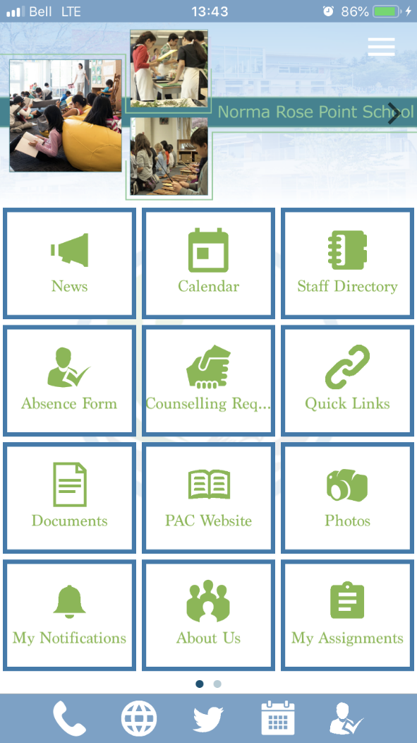
- PAC Website:
https://nrppac.wordpress.com/
- Hot Lunch & Volunteer Register:
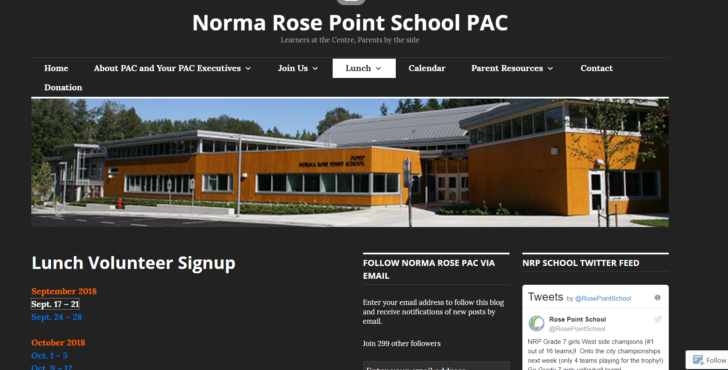
- Community Walking School Bus
- After School Programs
- Parent Information Events
- Math Club
- Clinics around UBC Campus
-Health
-Dental
- Community Centers
-Old Barn
-Wesbrook Community Center
-UNA Card
- Museums, Libraries, UBC Farm and education resources
- UBC Camps

